Privileged Identity Management for Global Administrator

- Login to Privileged Identity Management - Microsoft Azure
- Select Azure AD roles from the left pane
- Select Role from the left pane
- Find the Global Administration Role role and select
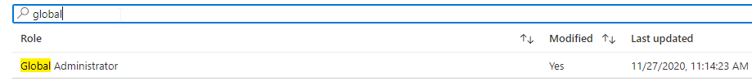

- Select Role settings and Edit

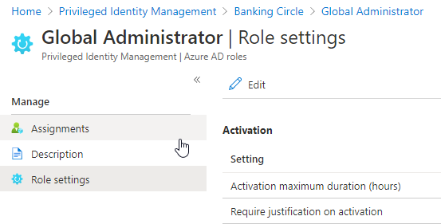
- The first step is Activation
- Activation maximum duration is set to 4 hours
- Select Require justification on Activation
- Next
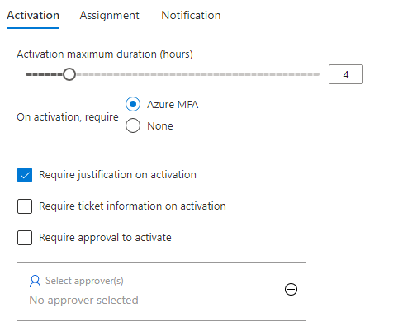

- Next, Assignment
- Select Allow permanent eligible assignment and Expire eligible assignments to after 1 Year
- Select Allow permanent active assignment and Expire eligible assignments to 6 Months
- Select Require justification on active assignment
- Next
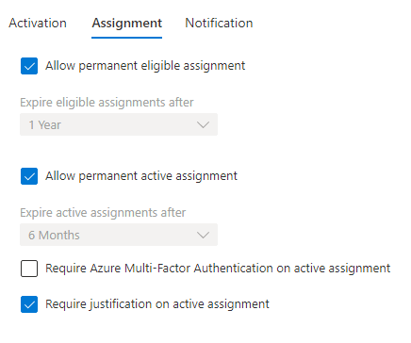

- Next, Notification
- Leave it as default settings and Update
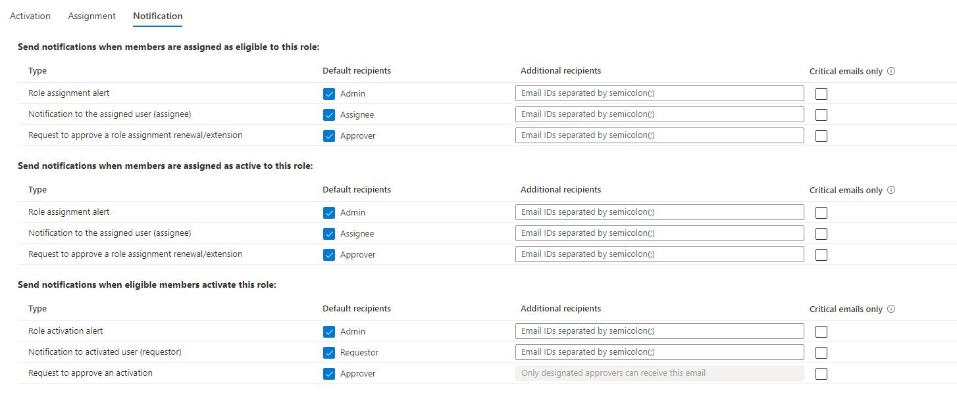
- Now, Back to Azure Ad roles
- Select Role from the left pane
- Find the Global Administration Role and select
- Select, Assignments from the left pane and Add Assignments
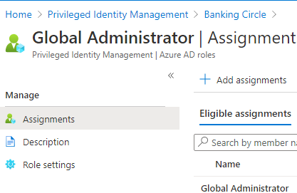

- Select No members selected
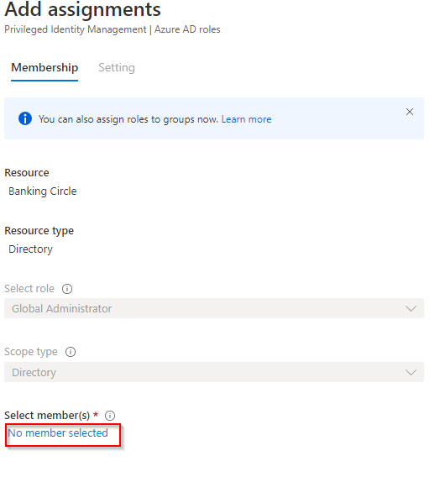

- Add the user and Select. Select Next
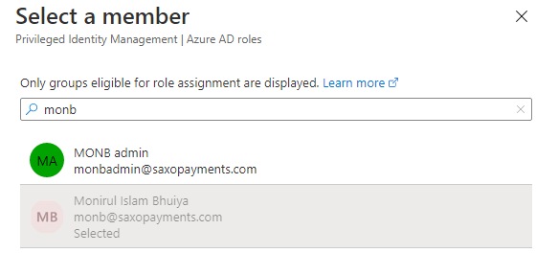

- Settings
- Assignment Type, Eligible
- Select Permanently eligible
- Assign

How to Activate Global Administration Roles

- Login to Privileged Identity Management - Microsoft Azure
- Select My Roles from the left pane
- Here you will find the Global Administrator role. Select Activate
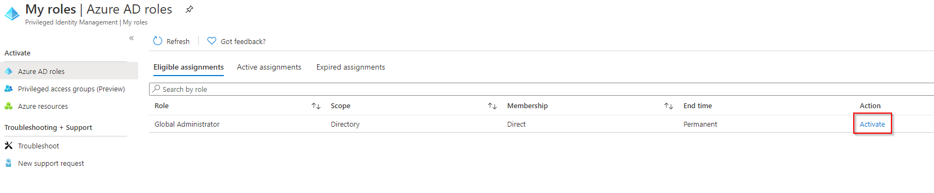
- Justify the Reason and Activate
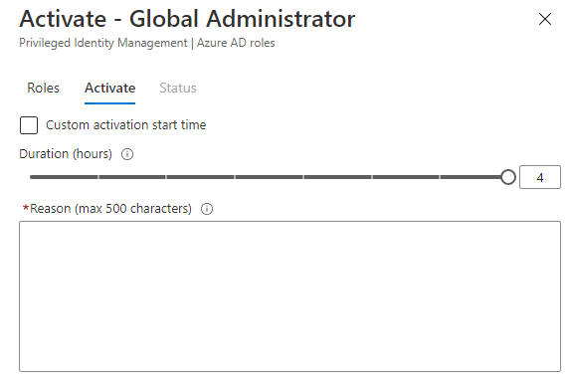

- Wait few seconds until activation process complete
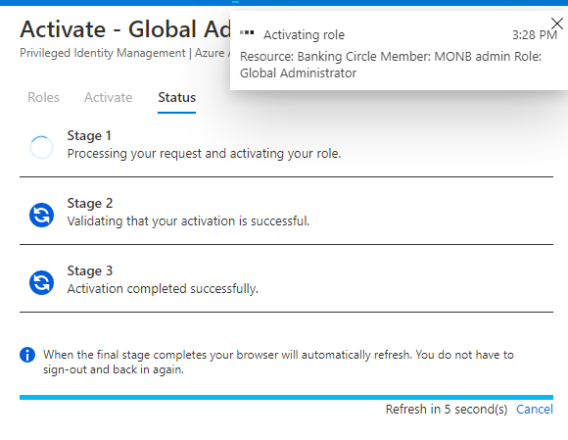
- To verify the access, Select My Roles from the left pane
- Select Active Assignment and check the status
